EXP 31. Prolog Program to Check Whether a Particular Bird Can Fly or Not
Aim: To determine whether a particular bird can fly or not using Prolog.
Program:
%%writefile bird.pl

bird(sparrow).
bird(parrot).
bird(pigeon).
bird(ostrich).
bird(penguin).

can_fly(sparrow).
can_fly(parrot).
can_fly(pigeon).

cannot_fly(Bird) :-
bird(Bird),
\+ can_fly(Bird).
Query and execution:

!swipl -q -s bird.pl -g "can_fly(sparrow), writeln('Sparrow can fly'), halt."
Output:
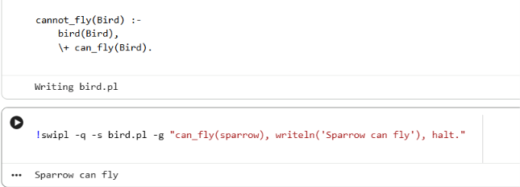

32. Prolog Program to Implement Family Tree
Aim: To implement family relationships such as mother, father, grandfather, grandmother, sister and brother.
Program:
The question gives genders but does not specify the parent-child connections. The following is a sample family tree to demonstrate the relations.

%%writefile family.pl

% Gender facts
female(pam).
female(liz).
female(ann).
female(pat).

male(tom).
male(bob).
male(jim).

% Sample parent relationships
parent(tom, liz).
parent(pam, liz).

parent(bob, ann).
parent(liz, ann).

parent(jim, pat).
parent(ann, pat).

% Mother relation
mother(X, Y) :-
female(X),
parent(X, Y).

% Father relation
father(X, Y) :-
male(X),
parent(X, Y).

% Grandfather relation
grandfather(X, Y) :-
male(X),
parent(X, Z),
parent(Z, Y).

% Grandmother relation
grandmother(X, Y) :-
female(X),
parent(X, Z),
parent(Z, Y).

% Sister relation
sister(X, Y) :-
female(X),
parent(Z, X),
parent(Z, Y),
X \= Y.

% Brother relation
brother(X, Y) :-
male(X),
parent(Z, X),
parent(Z, Y),
X \= Y.
Queries and outputs:
!swipl -q -s family.pl -g "mother(pam, liz), writeln('Pam is mother of Liz'), halt."
OUTPUT:

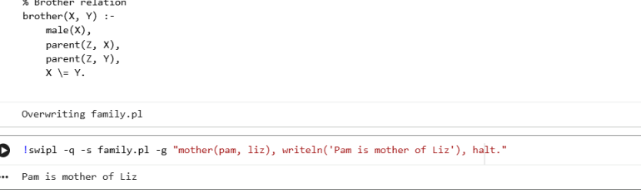
33. Prolog Program to Suggest Dieting System Based on Disease
Aim: To suggest a simple diet plan based on a disease.
Program:

%%writefile diet.pl

diet(diabetes, 'Balanced meals with controlled carbohydrates').
diet(hypertension, 'Low-salt diet with fruits and vegetables').
diet(obesity, 'Balanced calorie-controlled diet').
diet(anemia, 'Iron-rich foods such as beans and leafy greens').

suggest_diet(Disease, Diet) :-
diet(Disease, Diet).
Query:

!swipl -q -s diet.pl -g "suggest_diet(diabetes, D), write('Suggested Diet: '), writeln(D), halt."
OUTPUT:
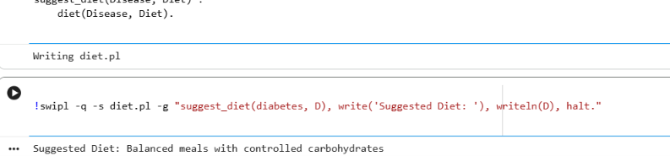
34. Prolog Program to Implement Monkey Banana Problem
Aim: To solve the Monkey Banana problem using Prolog.
Concept: The monkey wants to get bananas hanging from the ceiling. The monkey must move to the box, push it under the bananas, climb onto it and grasp the bananas.
Program:

%%writefile monkey.pl

% Initial state
initial_state(at(door), on(floor), at(window), has(no)).

% Goal
goal(has(banana)).

% Actions
move(at(X), at(Y)) :-
X \= Y.

push_box(at(X), at(Y)) :-
X \= Y.

climb(on(floor), on(box)).

grasp(has(no), has(banana)).

% Solution plan
solve([
move(door, middle),
push_box(middle, under_banana),
climb(box),
grasp(banana)
]).
Query:

!swipl -q -s monkey.pl -g "solve(Plan), writeln(Plan), halt."
Output:

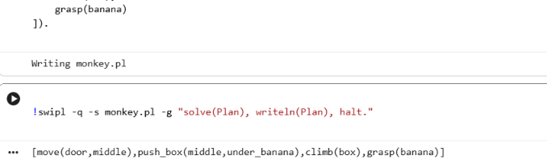
35. Prolog Program for Fruits and Their Colors Using Backtracking
Aim: To display fruit names and their colors using Prolog backtracking.
Program:

%%writefile fruit.pl

fruit(apple, red).
fruit(banana, yellow).
fruit(orange, orange).
fruit(grapes, green).
fruit(mango, yellow).

Query 1: Find the color of a fruit

!swipl -q -s fruit.pl -g "fruit(apple, C), write(C), halt."
OUTPUT
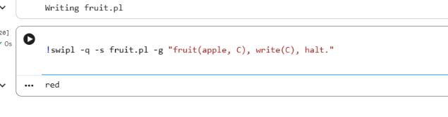
Query 2: Display all fruits and their colors using backtracking

!swipl -q -s fruit.pl -g "fruit(F, C), format('~w : ~w~n', [F,C]), fail."
OUTPUT:


